Program 1: Design and Implementation of a Full Adder Using VHDL
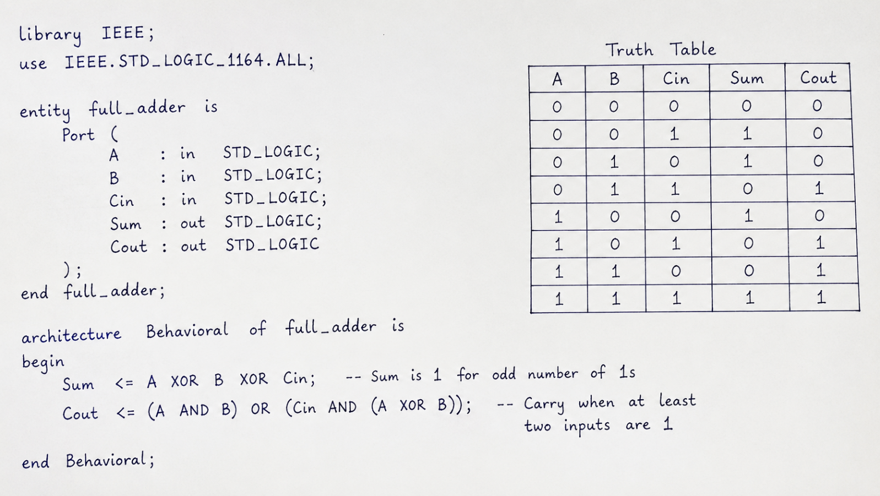

Figure 1: Block Diagram of 4-Bit Ripple Carry Adder Using Four Full Adders
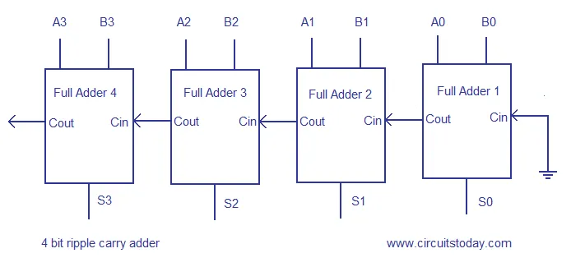

Program 2: Design and Implementation of a 4-Bit Ripple Carry Adder Using VHDL
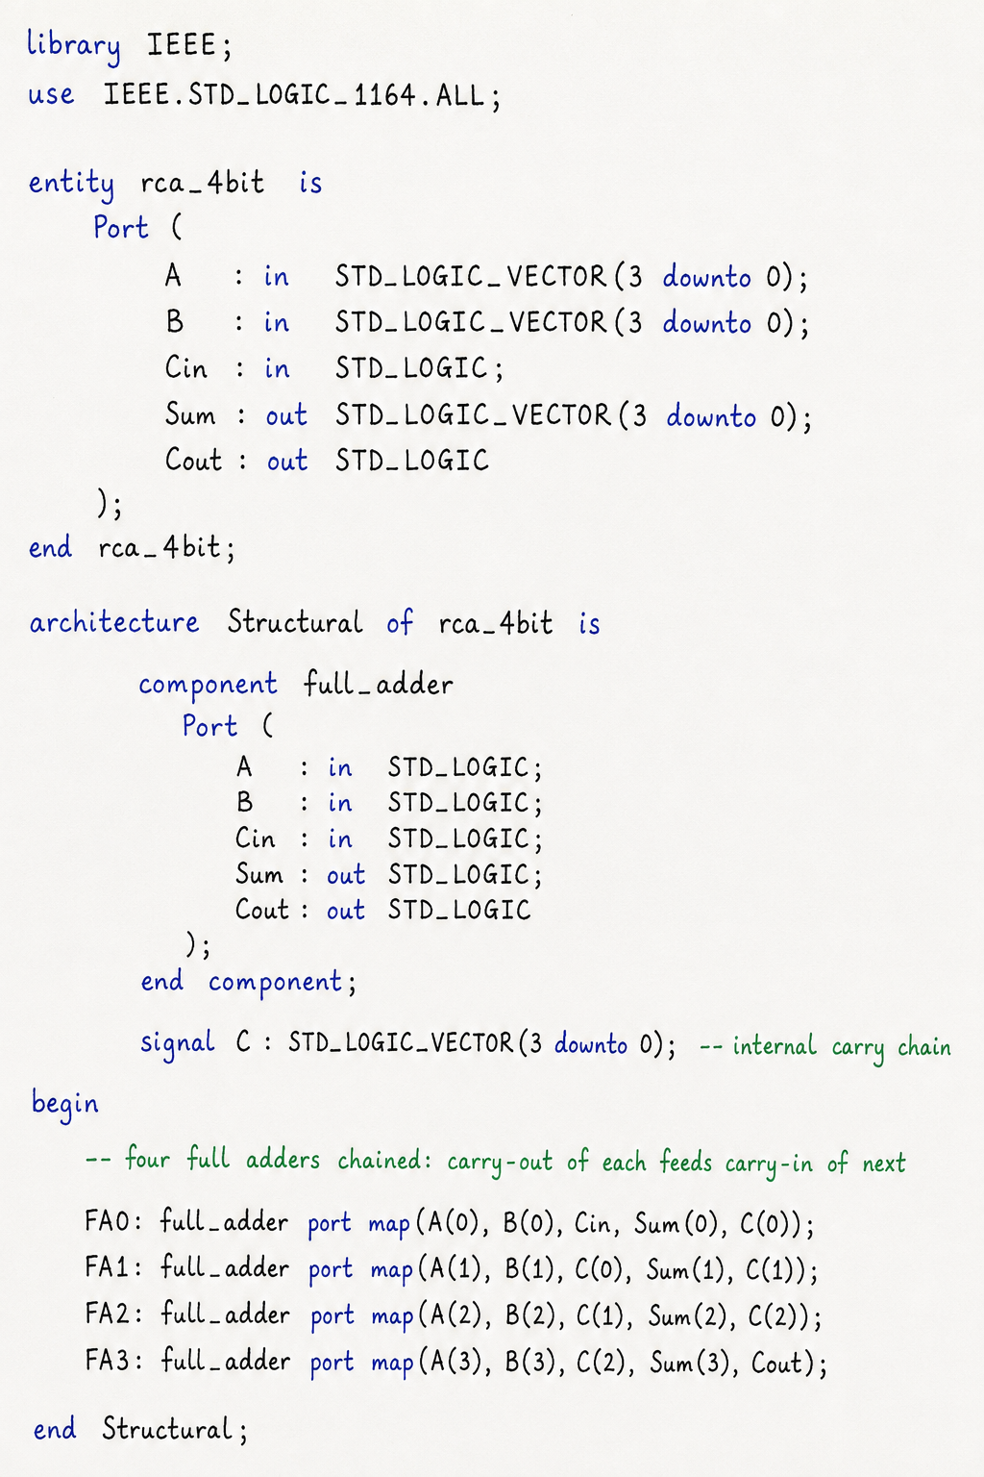
Program 3: Simulation and Verification of a 4-Bit Ripple Carry Adder Using Testbench
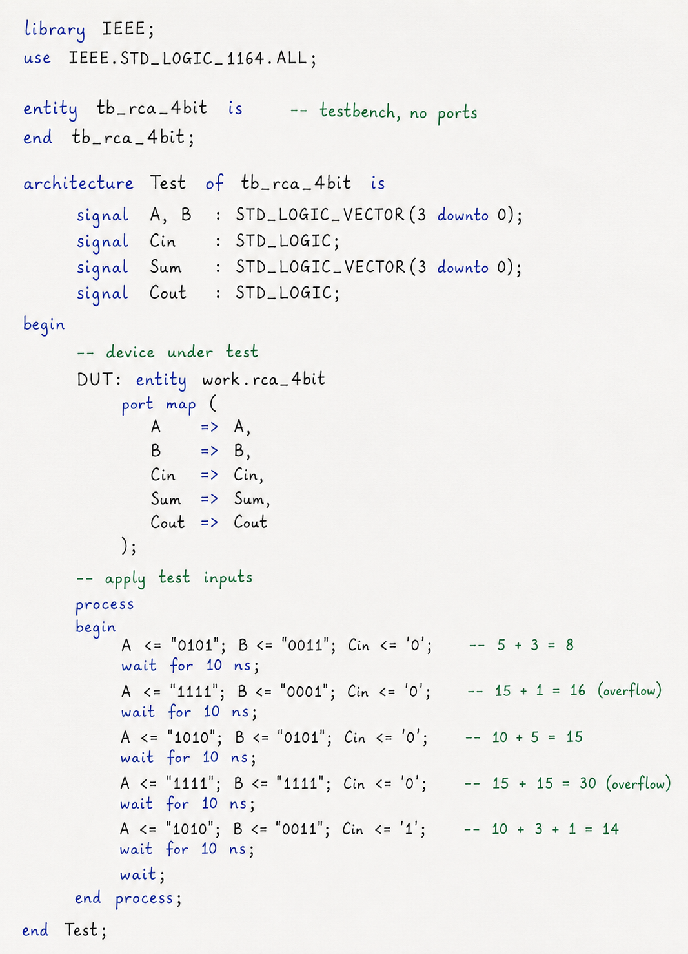
Figure 2: Simulation Waveform of 4-Bit Ripple Carry Adder in ModelSim